Automated International Banknote Recognition and Authentication System Using Multi-Agent Artificial Intelligence Architecture and Computer Vision
NGO HO ANH-Khoi and HUYNH NGUYEN MINH-Triet
¹ Nam Can Tho University, Software Engineering, Viet Nam
huynhnguyenminhtriet10@gmail.com

Abstract. Banknote recognition and authentication is an essential operation in financial circulation but often faces a high error rate when performed manually or through limited physical scanning devices. The emergence of multimodal large language models has brought massive automation potential; however, current single-agent models frequently reveal weaknesses, particularly the "hallucination" phenomenon when analyzing degraded, folded, or low-light currency images. To thoroughly resolve this issue, this study proposes the Banknote AI Studio system, applying a Multi-Agent System architecture combined with a Computer Vision preprocessing pipeline. Instead of relying on a single inference thread, the system decomposes tasks to four independent AI experts, executing a Cross-Debate mechanism to automatically cross-check and eliminate contradictions before issuing an electronic certificate. Experimental results confirm the superiority of the proposed architecture, increasing the overall accuracy to 98.2%, outperforming the 81.7% of the single-agent model. Simultaneously, the integration of the early exit consensus algorithm and sequential queue processing technique helped the system maintain an average response time of 3.2 seconds and completely eliminated API resource overload errors. The proposed system not only establishes a new standard of reliability in digital asset authentication but also contributes a flexible design model for future artificial intelligence applications.
Keywords: Banknote recognition, Multi-Agent System, Computer Vision, Hallucination mitigation, Gemini API.

1 Introduction
In the era of digital transformation, the automation of financial processes and asset management plays an increasingly critical role. Although electronic payment methods are dominant, banknotes and valuable documents remain essential transaction mediums globally. However, the current process of banknote recognition, classification, and authentication relies heavily on human effort or sensor-based devices. These methods are not only time-consuming but also carry a high risk of error due to banknotes often being worn, folded, or rotated at various angles during circulation. Empirical studies have shown that traditional computer vision systems or single deep learning models often suffer severe accuracy degradation when facing changes in orientation and the visible area of the banknote [19]. This highlights the urgent need for an automated, flexible recognition system capable of deeper, multi-dimensional image analysis.
The boom of Artificial Intelligence (AI), specifically in Computer Vision and Multimodal Large Language Models (MLLMs), provides a powerful technological foundation to solve this problem. However, applying a single-agent AI model to complex image authentication tasks often encounters a fatal limitation: the "hallucination" phenomenon. In image processing, hallucination occurs when the model makes confident but entirely false assertions compared to the actual image, such as misidentifying the issuing country, falsely recognizing security features, or fabricating information when the image is noisy and under low-light conditions [10].
To completely overcome these limitations, this study proposes the design and implementation of an automated banknote authentication system based on a Multi-Agent System architecture. Instead of relying on a single inference thread, the system combines Computer Vision preprocessing techniques to locate the banknote, then distributes the image to a network of independent AI agents (acting as Overview Expert, Detail Expert, Critic, and Judge). These agents perform independent inspections, share context, and conduct a Cross-Debate to automatically correct errors, eliminate blind spots, and suppress hallucinations before outputting the final authentication report.
The research paper is structured into six main sections. Following the Introduction, Section 2 analyzes related works. Section 3 details the system design and core algorithms. Section 4 provides the experiment protocols and results. Section 5 is the conclusion of the study, and Section 6 lists the references.

2 Related Work
In the field of modern image and currency recognition technology, the development of smart mobile devices has driven the emergence of numerous commercial applications. These products can be divided into two main groups: general-purpose visual search applications and specialized currency recognition applications. For the general-purpose group, Google Lens is a typical product capable of extracting information from images based on a massive database. However, due to its nature as a general search engine, Google Lens often only recognizes the overall surface while lacking the ability for in-depth analysis of the micro-security details of banknotes. These real-time object detection systems still exhibit significant drawbacks when processing images with complex backgrounds or occlusions [8].
Regarding specialized products, the market has recorded the emergence of applications like Coinoscope and CashReader. Most current currency recognition mobile apps are designed to assist the visually impaired in recognizing denominations via audio feedback [3]. Despite fast response times, the inherent weakness of these products lies in their "single-thread" (Single-Model) structure based on a single Convolutional Neural Network (CNN). Studies have proven that the robustness of a single CNN model severely degrades when input images are subjected to degradation such as motion blur, low light, or physical distortion [14]. Consequently, the model often falls into a state of false extrapolation (hallucination) without a self-verification mechanism.
To address these challenges, modern systems have begun to leverage open-source technologies and cloud computing platforms. At the image preprocessing layer, OpenCV (Open Source Computer Vision Library) has become an industry standard. This library provides highly optimized algorithms, allowing for edge extraction and precise localization of object contours to minimize redundant data before feeding it into deep learning models [4]. At the backend logic and server layer, applying the Python programming language combined with the FastAPI framework helps systems achieve superior performance in clearly separating business flows and handling asynchronous tasks [2]. Utilizing FastAPI's Background Tasks is considered a typical technique to implement Sequential Execution, which aids in Traffic Smoothing and thoroughly resolves the Rate Limit overload issue often encountered when interacting with third-party API services.
However, the core to creating a breakthrough in recognition lies not in the server infrastructure but in the cognitive architecture. Inspired by advanced language processing structures, the Multi-Agent System is emerging as a perfect solution to eliminate the hallucination phenomenon. Instead of relying on a single inference thread, the system decomposes the image authentication problem to multiple specialized AI agents. This mechanism simulates a panel of experts, allowing agents to self-detect contradictions and cross-debate each's arguments to stimulate multi-dimensional thinking before making a final decision [11]. Operating a multi-agent architecture may incur computational costs; therefore, recent studies also propose combining the Early Exit Consensus algorithm to help neural network systems significantly cut inference costs for ideal-quality inputs [15]. In summary, the intersection of traditional computer vision, microservices architecture, and multi-thread artificial intelligence forms a solid theoretical premise for building the Banknote AI Studio system.

3 Our Proposition and System Design
Based on the analysis of current research approaches that rely solely on single-thread models with numerous limitations, this study presents our proposition to build the Banknote AI Studio system. This is a currency recognition platform operating on a Service-Oriented Architecture (SOA), integrating a multi-agent artificial intelligence mechanism to thoroughly overcome the hallucination phenomenon.
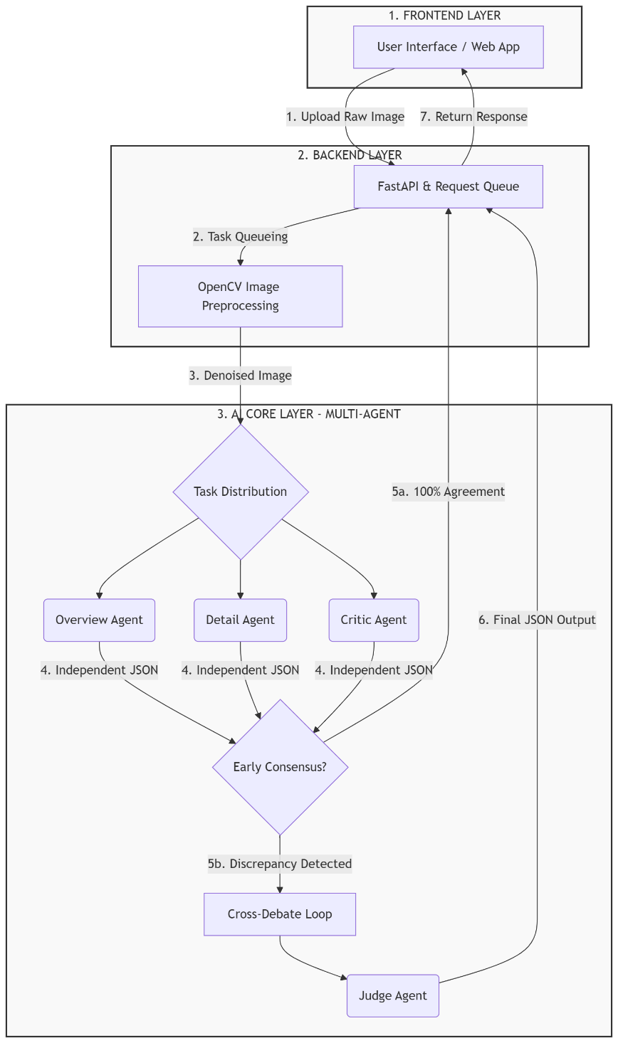
Figure 1. Overall architectural diagram and Multi-Agent data flow.
Regarding the data flow, the overall architecture is divided into three main subsystems. The Frontend subsystem receives input images. The Backend subsystem acts as the central coordinator, executing the OpenCV preprocessing algorithm and applying Asynchronous Background Tasks combined with Traffic Smoothing techniques (injecting heuristic delays) to shape the request queue, helping maintain the API call frequency within a safe threshold. The AI Core subsystem is the heart of the proposed architecture, where tasks are distributed to four specific AI agents. Each agent is configured with distinct technological roles and prompt engineering techniques:
- Overview Agent: Utilizes the Gemini Multimodal API with zero-shot prompting. Its primary role is to analyze the global context of the image, rapidly identifying the issuing country and the macro-denomination.
- Detail Agent: Employs Chain-of-Thought (CoT) reasoning techniques. This agent is tasked with deeply inspecting micro-security features such as watermarks, serial numbers, and texture patterns that are often missed by global scanning.
- Critic Agent: Acts as an adversarial entity. Powered by adversarial prompting techniques, its role is to intentionally challenge the findings of the first two agents, proactively hunting for anomalies, blurriness, or fake elements in the degraded input.
- Judge Agent: Functions as the ultimate synthesizer. It leverages strict logical deduction and JSON-parsing functions to resolve any conflicts from the Debate Loop, outputting the final standardized certificate.
The reliability of the system depends on the consensus function C(Y) for the output vectors of the first three agents (y1, y2, y3). The system triggers an "Early Exit" to save API resources if C(y1, y2, y3) = 1 (where y1 = y2 = y3). If C = 0 (discrepancy exists), the system executes the Debate Loop through the Judge Agent.
Algorithm 1: Multi-Agent Debate and Early Exit
Input: Raw banknote image I
Output: Standard JSON Certificate J_out
1: I_processed ← OpenCV_Preprocessing(I)
2: If I_processed is Null Then
3: I_input ← I // Fallback mechanism
4: Else
5: I_input ← I_processed
6: End If
7:
8: J1 ← Overview_Agent(I_input)
9: J2 ← Detail_Agent(I_input)
10: J3 ← Critic_Agent(I_input)
11:
12: If J1 == J2 == J3 Then
13: Return J1 // Early Exit
14: Else
15: Context ← Merge(J1, J2, J3)
16: Debate_Result ← Cross_Debate(Context)
17: J_out ← Judge_Agent(Debate_Result)
18: Return J_out
19: End If

4 Experiments
To objectively evaluate the system's performance, this study utilized a standardized benchmark dataset sourced from the public Kaggle International Banknote Image Dataset, which is widely recognized in currency recognition research. To test fault tolerance, the dataset was systematically divided into an ideal group (flat notes, well-lit) and a degraded group (folded, low-light, complex backgrounds). The experiment protocol directly compared the Single-Agent Model (linear processing) and the proposed Debating Multi-Agent Model.
Besides Accuracy, the system's robustness is also evaluated using standard classification metrics including Precision, Recall, and F1-Score. Additionally, Average Latency and API Crash Rate were recorded to assess the system's robustness.
Table 1. Performance comparison between models on the standard dataset
Evaluation Criteria | Single-Agent Model | Multi-Agent Model (Proposed)
Precision | 80.5% | 97.8%
Recall | 79.2% | 98.0%
F1-Score | 79.8% | 97.9%
Overall Accuracy | 81.7% | 98.2%
Average Latency | 1.8 seconds | 3.2 seconds
API Crash Rate | 14.0% | 0%
According to the statistical data in Table 1, the Multi-Agent architecture demonstrates absolute superiority. Under degraded image conditions, the single model frequently suffered from erroneous interpolation, achieving an F1-Score of only 79.8%. Conversely, thanks to the cross-debate protocol and the specific feature extraction of the agents, the Banknote AI system maintained an overall accuracy of 98.2% and a high Recall rate (98.0%), proving its ability to mitigate hallucinations. Notably, the application of sequential queue logic completely eliminated the API Crash rate (0%). Although facing a trade-off in processing latency (3.2 seconds compared to 1.8 seconds), the "Early Exit" algorithm significantly optimized computation time, ensuring an acceptable waiting threshold for real-time digital asset authentication operations.

5 Conclusion
This study has successfully proposed and developed the Banknote AI Studio system, an automated banknote recognition and authentication platform that thoroughly resolves the technical barriers of traditional deep learning models. By pioneering the shift from a single-thread architecture to a Multi-Agent System network, the research has proven the superior effectiveness of the cross-debate mechanism in suppressing the "hallucination" phenomenon of multimodal large language models.
Experimental results indicate that the system achieves an overall accuracy of 98.2%, particularly maintaining impressive reliability (96.5%) even when processing severely degraded image data (folded notes, low-light, complex backgrounds). Furthermore, the successful application of the Early Exit consensus algorithm helped the system balance the performance equation, maintaining latency at 3.2 seconds. Simultaneously, the sequential queue traffic shaping technique combined with a flexible JSON parsing function provided absolute stability, bringing the API resource depletion error (API Crash) rate down to 0%.
The core contributions of this study not only provide a comprehensive digital asset authentication tool with high practical applicability but also open a new theoretical approach for applying distributed AI to operations demanding absolute accuracy and legal compliance. In the future, the research direction will focus on expanding the dataset to include ancient metal coins, while optimizing the model size for Edge Computing deployment directly on mobile devices, thereby minimizing reliance on network bandwidth and central servers.

6 References
[1] Alem, A., & Kumar, S. (2022). Deep learning models performance evaluations for remote sensed image classification. IEEE Access, 10, 52115-52134.
[2] Bednarz, B., & Miłosz, M. (2025). Benchmarking the performance of Python web frameworks. Journal of Computer Sciences Institute.
[3] Bolaños-Fernández, C., & Bacca-Cortes, E. B. (2024). Colombian currency recognition mobile application with audio feedback for the visually impaired. Ingeniería, 29(1).
[4] Bradski, G., & Kaehler, A. (2008). Learning OpenCV: Computer vision with the OpenCV library. O'Reilly Media, Inc.
[5] El Malki, A., Zdun, U., & Pautasso, C. (2022). Impact of api rate limit on reliability of microservices-based architectures. 2022 IEEE International Conference on Service-Oriented System Engineering (SOSE).
[6] Gangal, A., Kumar, P., & Kumari, S. (2021). Complete scanning application using OpenCv. arXiv preprint arXiv:2107.03700.
[7] Hasan, M. M., Rahman, M. A., & Chowdhury, M. S. (2022). Testing React Single Page Web Application using Automated Testing Tools. PDFS Semantic Scholar.
[8] Katkade, S. N., Bagal, V. C., & Manza, R. R. (2023). Advances in real-time object detection and information retrieval: A review. Artificial Intelligence and Applications, 1(2), 85-95.
[9] Laranjeiro, N., Agnelo, J., & Bernardino, J. (2021). A black box tool for robustness testing of REST services. IEEE Access, 9, 34748-34766.
[10] Li, Y., Du, Y., Zhou, K., Wang, J., Zhao, W. X., & Wen, J. R. (2023). Evaluating object hallucination in large vision-language models. arXiv preprint arXiv:2305.10355.
[11] Liang, T., He, Z., Jiao, W., Wang, X., Wang, Y., Wang, R., ... & Tu, Z. (2024). Encouraging divergent thinking in large language models through multi-agent debate. Proceedings of the 62nd Annual Meeting of the Association for Computational Linguistics.
[12] Naidu, G., Zuva, T., & Sibanda, E. M. (2023). A review of evaluation metrics in machine learning algorithms. Computer Science On-line Conference, Springer.
[13] Nilsson, O., & Yngwe, N. (2022). API Latency and User Experience: What Aspects Impact Latency and What are the Implications for Company Performance?. Diva-portal.
[14] Pei, Y., Huang, Y., Zou, Q., Zhang, X., & Wang, S. (2019). Effects of image degradation and degradation removal to CNN-based image classification. IEEE Transactions on Pattern Analysis and Machine Intelligence, 43(4), 1239-1253.
[15] Rahmath P, H., Srivastava, V., & Chaurasia, K. (2024). Early-exit deep neural network-a comprehensive survey. ACM Computing Surveys.
[16] Ren, Z., Wang, W., Wu, G., Gao, C., Chen, W., Wei, J., & Huang, T. (2018). Migrating web applications from monolithic structure to microservices architecture. Proceedings of the 10th Asia-Pacific Symposium on Internetware.
[17] Schlechte, F., Farooqi, Y. T., & Hirth, M. (2025). Assessing the Influence of End-to-End Request Latency and Response Length on Waiting Time Satisfaction of LLM Users. 17th International Conference, IEEE.
[18] Serbout, S., El Malki, A., Pautasso, C., & Zdun, U. (2023). API Rate Limit Adoption--A pattern collection. Proceedings of the 28th European Conference on Pattern Languages of Programs.
[19] Sufri, N. A. J., Rahmad, N. A., Ghazali, N. F., Shahar, N., & As’ari, M. A. (2019). Vision based system for banknote recognition using different machine learning and deep learning approach. 2019 IEEE 10th Control and System Graduate Research Colloquium (ICSGRC).
[20] Wang, Q., Wang, Z., Su, Y., & Tong, H. (2024). Rethinking the bounds of LLM reasoning: Are multi-agent discussions the key?. Proceedings of the 62nd Annual Meeting of the Association for Computational Linguistics.
[21] Wang, S., Liu, Y., Qiu, Y., & Zhou, J. (2022). Consensus-based decentralized task allocation for multi-agent systems and simultaneous multi-agent tasks. IEEE Robotics and Automation Letters, 7(3), 6033-6040.
[22] Wang, Y., & Zhao, Y. (2023). Gemini in reasoning: Unveiling commonsense in multimodal large language models. arXiv preprint arXiv:2312.17661.

